First Grade Student Schedule
Instructional Delivery Model | Time | Activity
(LIVE) | SEL (Check-In)  7:45 - 8:00 | SEL (Check-In)  (15 min,/Synchronous- LIVE)
(LIVE | Reading  8:00 - 8:20 | Reading  Teach Foundational Reading Skills/Green Band  (20 min./Synchronous -Live)
 | Reading  8:20-8:40 | Reading Independent Activities  Asynchronous/Unplugged -(20 minute)
Break
8:40-8:50
(LIVE) | Language Arts  8:50 - 9:20 | Language Arts/Writing/Social Studies Integrated  (and/or) Small Group Instruction  (30 min./Synchronous-Live)
Break
9:20- 9:30
 | Reading  9:30- 9:55 | Reading Integration Activities  (25 min./Asynchronous-Independent Work)
(LIVE) | Science/Social Studies  9:55- 10:25 | Non-Integrated Subject- LIVE  Science- 30 min
(LIVE) | Math  10:25- 11:00 | Math (35 min./Synchronous- LIVE)
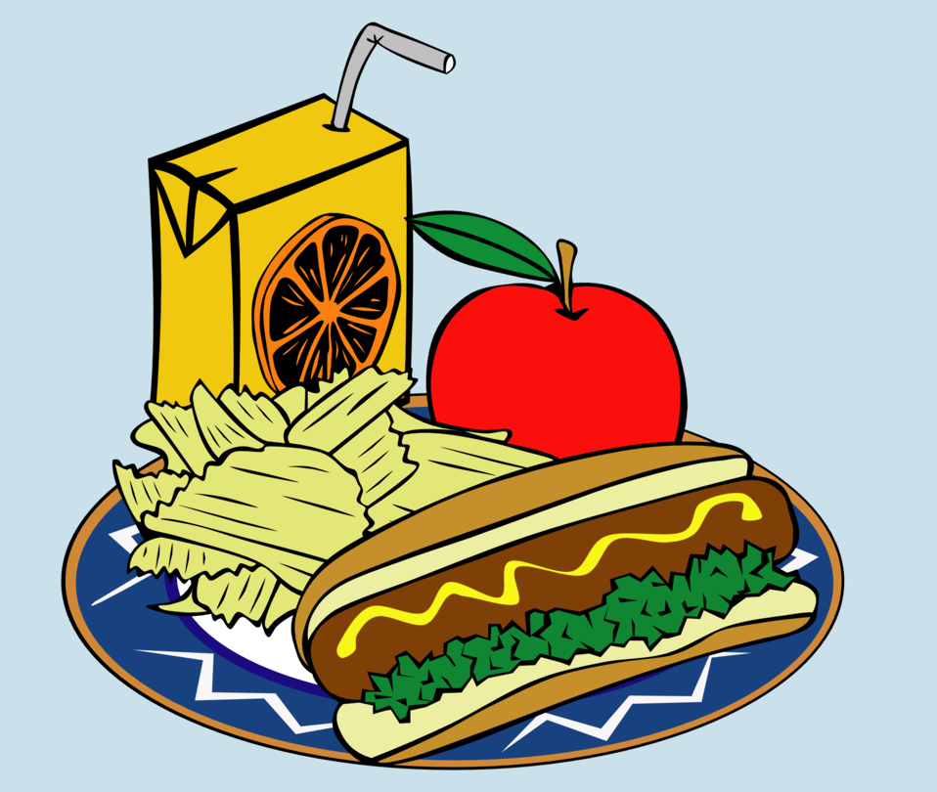 | Lunch 11:00 - 11:40 | LUNCH -40 minutes
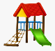 | 11:40-11:55 | RECESS – 15 minutes
(LIVE) | Math Wrap-Up  11:55- 12:00 | Math Wrap Up- (5 min/Synchronous- LIVE)
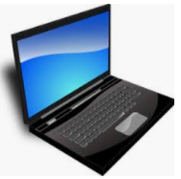 | Math Small Group  12:00-12:10 | Math Small Group  (10 min. Asynchronous- Small Group)
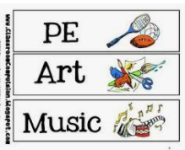 | Exploratory  12:10- 12:50 | Exploratory  (Synchronous-LIVE)  40 min
 | BREAK  12:50- 1:00 | Break  10 min
 | Math  1:00-1:30 | Math Small Group  (30 min Asynchronous- Independent Work)

